- Research Gaps and Our Contributions
Existing interpretable multitask models often cannot identify nodules on their own, meaning that they require nodule locations or masks as input. Moreover, they typically connect several separately trained models, with little supervision or interaction between components. In contrast, models that process an entire CT scan often do not produce voxel-level masks or semantic features. The use of hard masks can also block gradients from the downstream diagnostic task from reaching the segmentation model. Yet these masks and features are nearly as important as the final predicted risk because nodule assessment is inherently subjective: different clinicians may assign different boundaries, semantic attributes, and malignancy ratings to the same nodule. Therefore, a single, opaque risk score is not sufficient to support clinical judgment on its own, as it does not reveal which nodule masks or imaging findings drove the prediction.

To address both limitations, we propose a complete framework for analyzing whole CT scans. Our model first passes the entire CT scan through a segmentation model to generate a mask of all nodules in the scan. A multichannel deep learning model then separates this whole-scan mask into masks for individual nodules. Next, the model extracts radiomic and semantic features from each nodule and uses them to predict malignancy. Gradients can flow through nearly the entire framework, allowing downstream tasks to guide upstream components during training. This shared training process may enable our model to perform better than interpretable multitask models that simply connect separately trained components. Compared with fully black-box deep learning models, our framework also provides greater interpretability by producing a mask and a set of features for each nodule, both of which can provide important evidence for clinical diagnosis.

- Model Structure
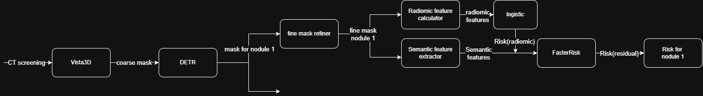

- Evaluation
  - Per Volume
End to end patient risk
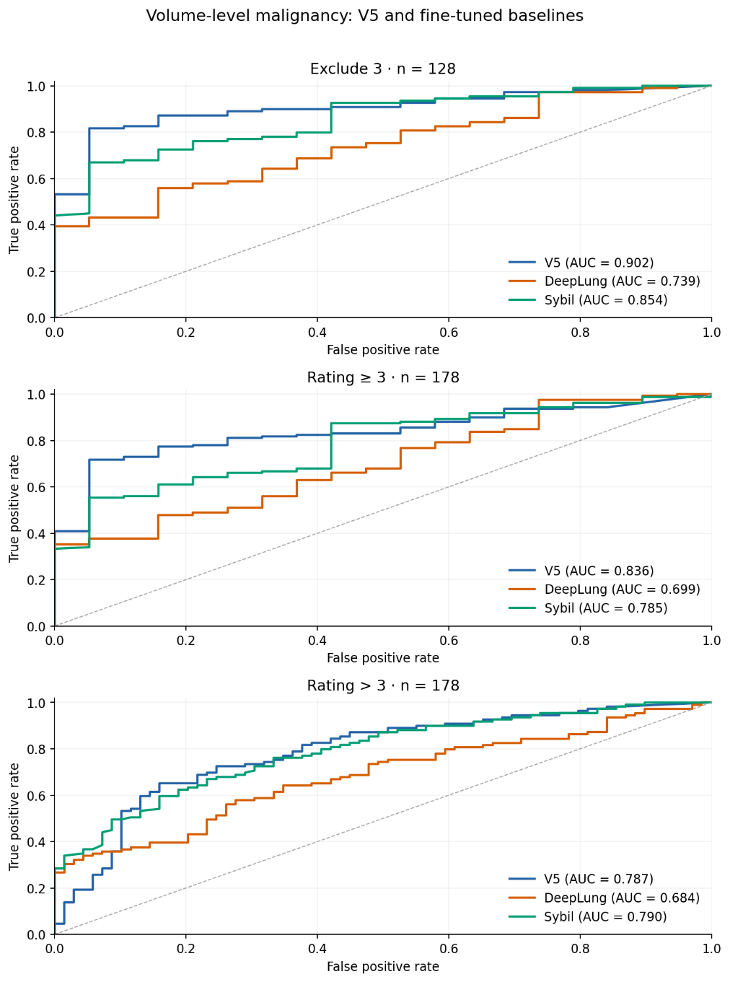

FROC of nodule detection
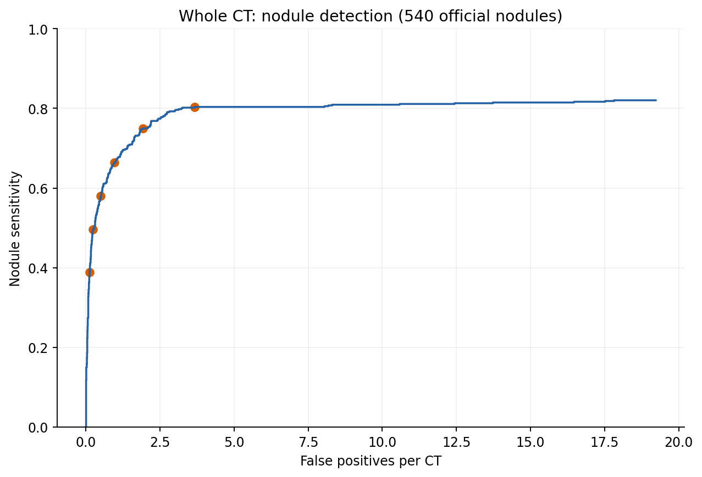

  - Per Annotation
Using official LIDC feature to predict malignancy with the malignancy model trained
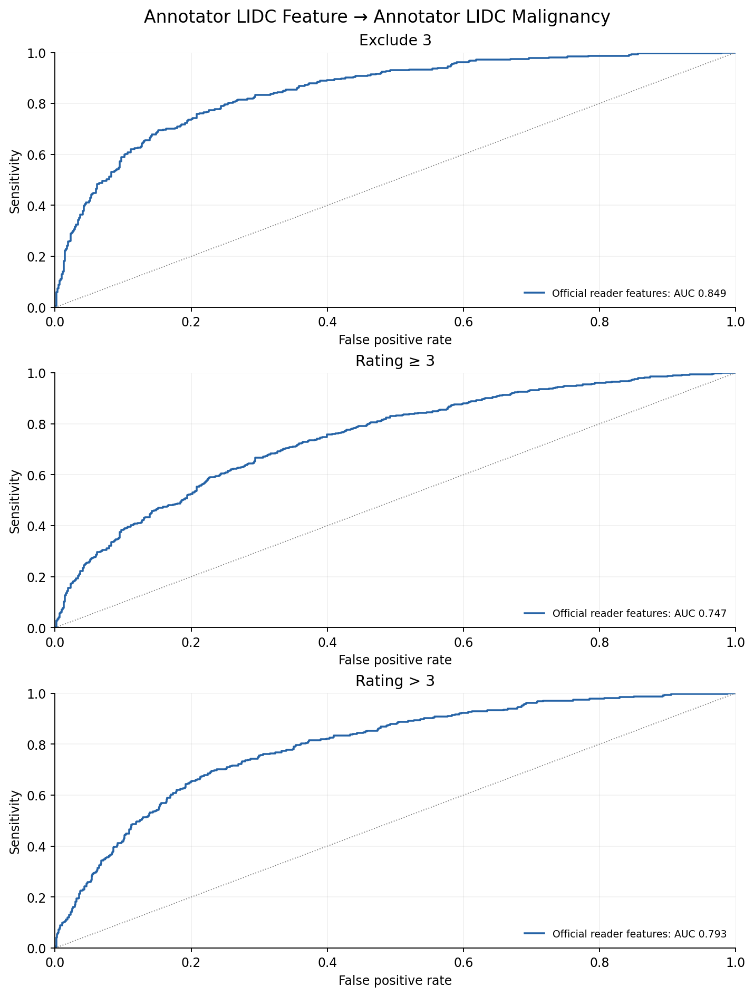

Using official mask to predict semantic features
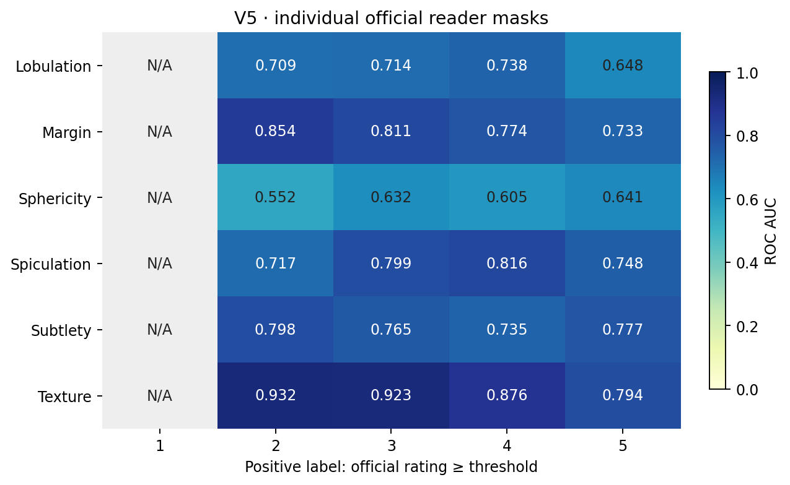

  - Per Nodule
Predicted nodule mask to semantic features
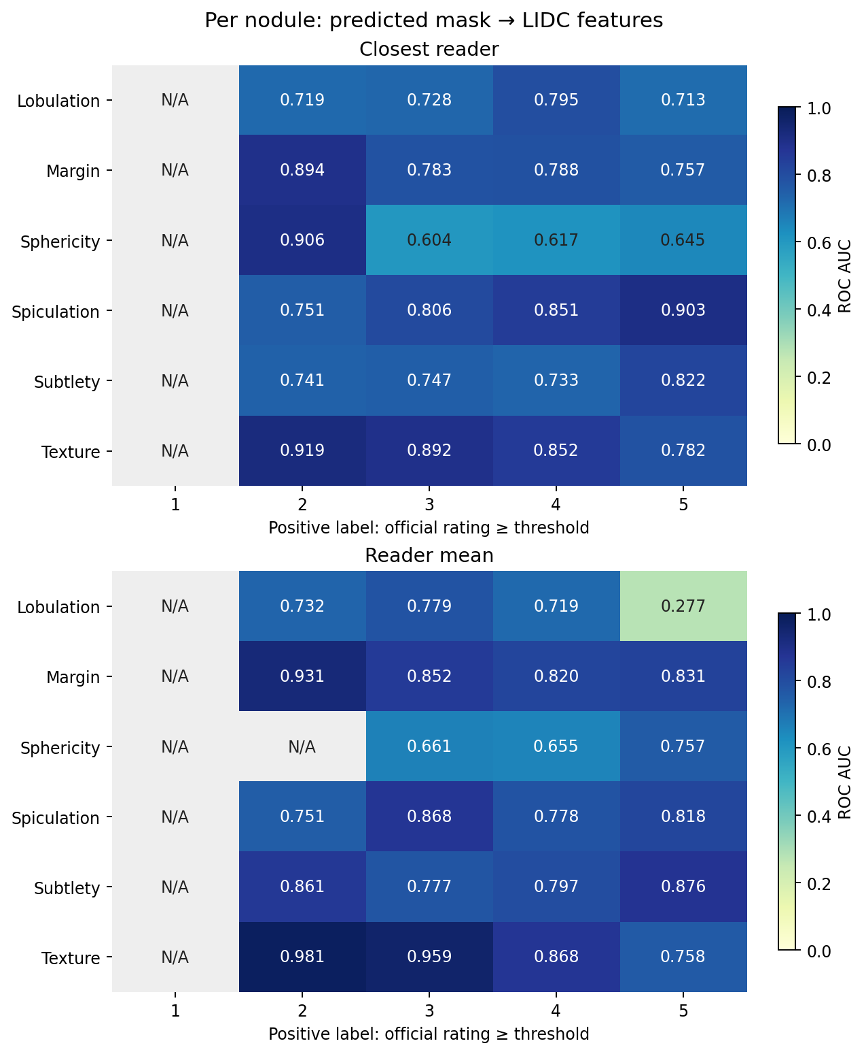

Nodule level malignancy (detected nodules only)
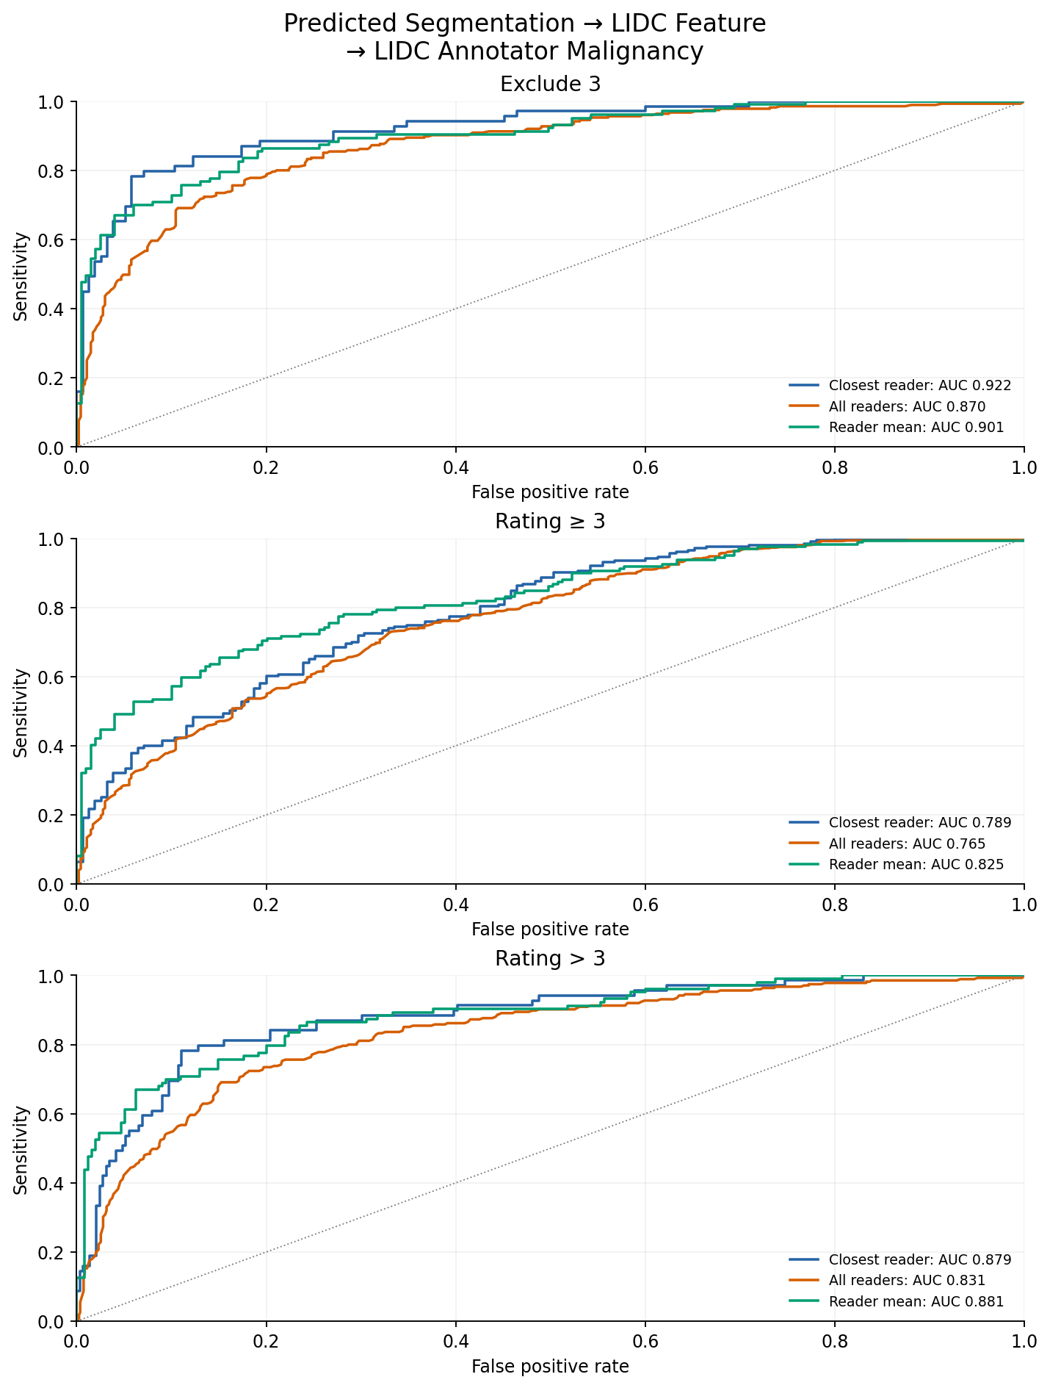

Nodule level malignancy (including missing nodules)
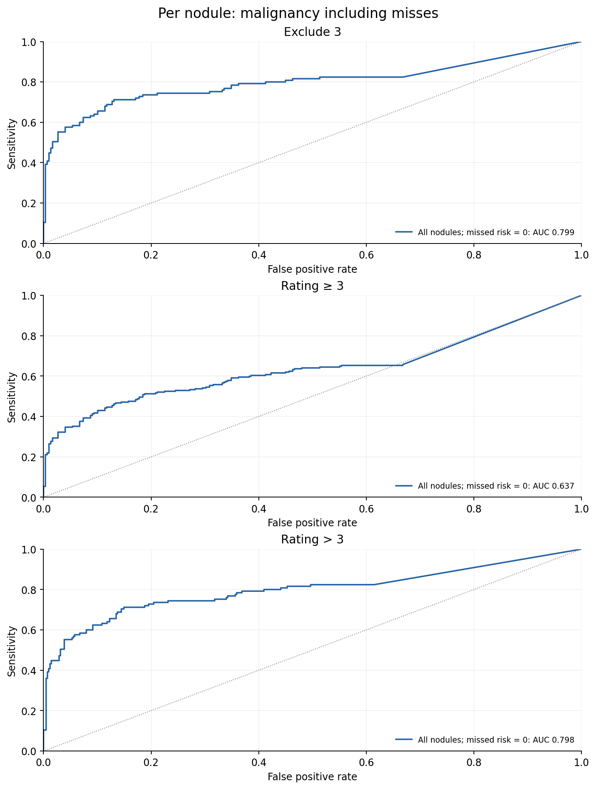

Dice/IoU: Among 540 nodules in total, 358 have been detected.
